# Creating Breadcrumbs using Dynamic Navigation

Dynamic navigation relies on keyword taxonomy. The sitemap is generated based on the keyword hierarchy in Tridion. To implement breadcrumbs we need to first create the taxonomy in tridion then create the breadcrumb in project files

## Create Breadcrumb component in Tridion

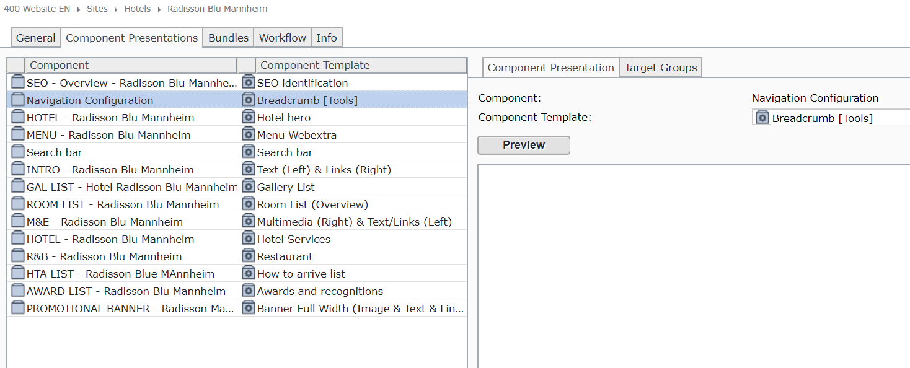Go to 400 Website EN 🡪 Sites 🡪 Hotels 🡪 [hotel name] 🡪 page. Then go to the Component Presentation tab.

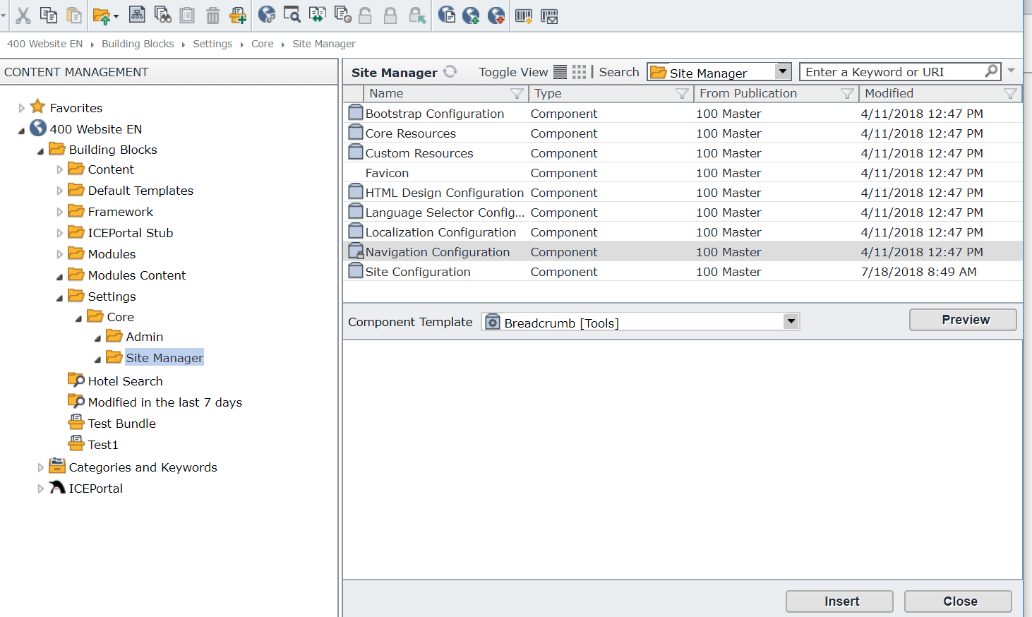Click insert, then in the new window navigate to settings🡪core🡪site manager🡪navigation configuration. Choose breadcrumb[tools] and insert. Lastly arrange to desired position.

## Create navigation keywords in Tridion

There are three requirements for creating navigation keywords in Tridion

1. The category name must have the name “navigation” in it. (also must be in 400 publication)
2. The keyword value field must be prefixed with a three digit number indicating the order (smaller numbered keywords appear first). If no number is present, the keyword won’t be displayed.

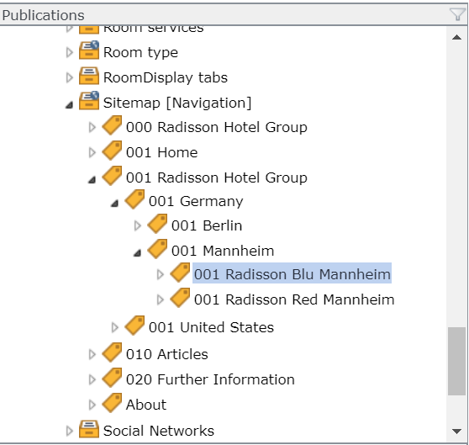

1. The keyword must be normal (non-abstract) for it to be linkable with pages.

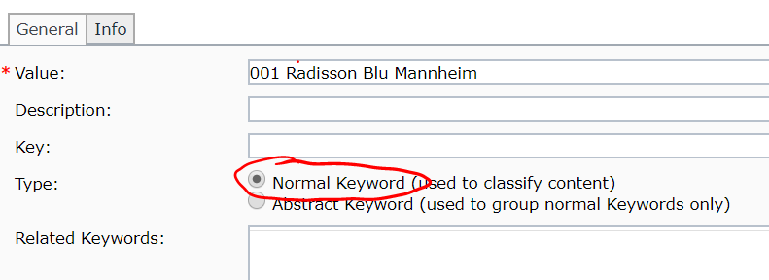

## Linking keywords to webpages

Go to page 🡪 general 🡪metadata Schema 🡪page Navigation Metadata. Then select the appropriate keyword from the category. This ensures the keyword is clickable in the breadcrumb section. This has to be done for both pages that actually display the breadcrumb and the pages the breadcrumb directs to. Because this is dynamic, the linking must be done manually.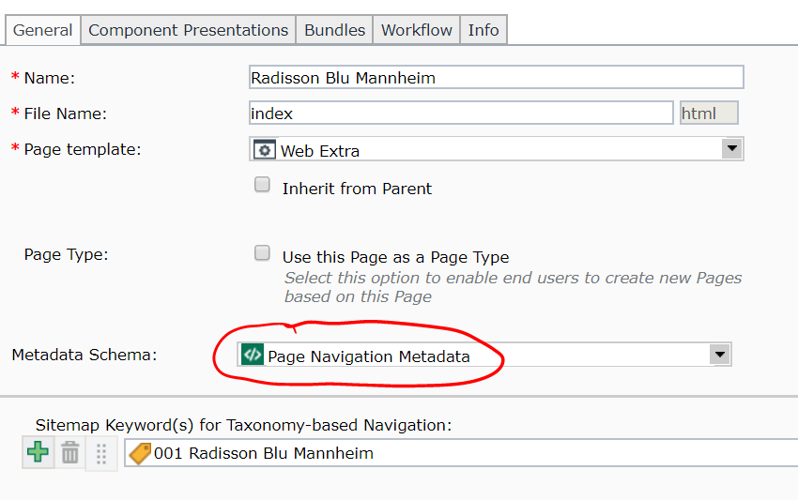

## Enable dynamic navigation

Now the Tridion part is done, the project code must be edited to display breadcrumbs correctly. To enable dynamic navigation based on keyword taxonomy as oppose to the default static, configure the “**dxa.properties**” file located in src/main/resources.

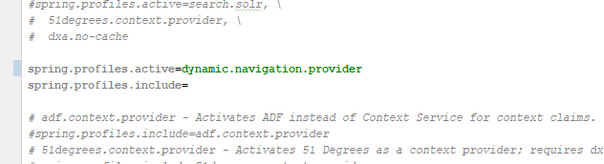

## Write the display of Breadcrumb

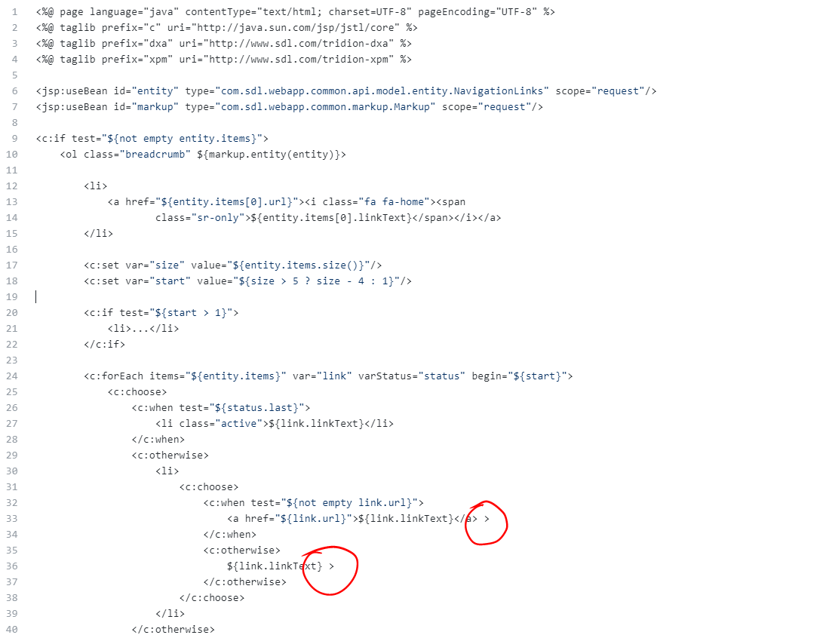This the “breadcrumb.jsp” file determining how it looks on the website. The circled area determine separators between keywords (e.g. Germany > Mannheim > Hotel Mannheim)

The file belongs in src/main/webapp/WEB-INF/Views/Core/Entity. It can be downloaded from <https://github.com/sdl/dxa-modules/edit/master/webapp-java/dxa-module-core/src/main/resources/META-INF/resources/WEB-INF/Views/Core/Entity/Breadcrumb.jsp>

## Include the Breadcrumb in Webpage

1. First add the breadcrumb in moduleinitilizer, which is located in src/main/java/com.ey.radisson/dxa.modules/core/

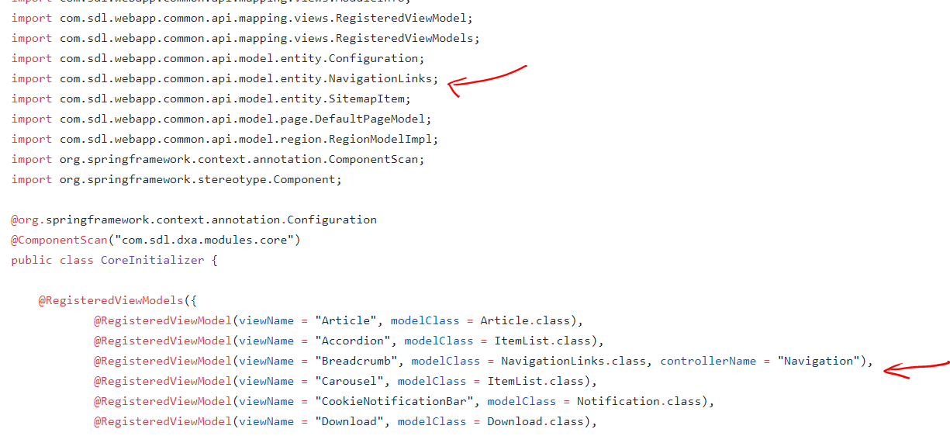

1. Create a tools region. Name it Tools.jsp and put it in src/main/webapp/WEB-INF/Views/Core/Region/ along with the header and footer.

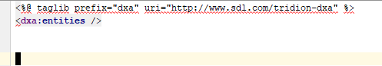

1. Finally, add the tools region in the webextra design in src/main/webapp/WEB-INF/Views/Core/Page/WebExtraPage.jspx

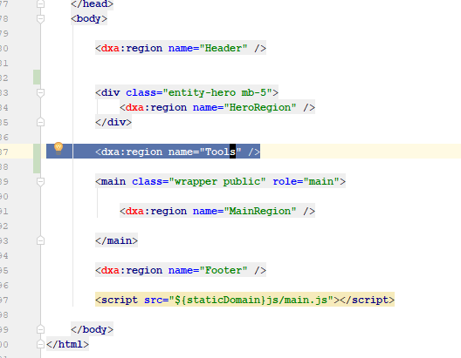

## Publish and Done!